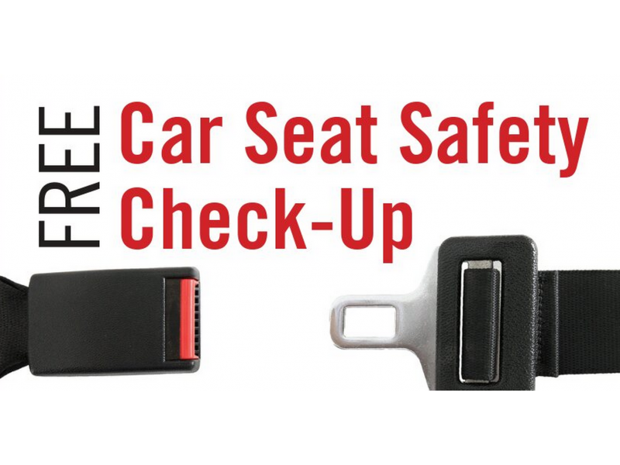

95% of child safety seats are misused

- Is your child’s car seat properly installed?
- Is your child in the appropriate seat?
- Has your child’s car seat been recalled?

Have your child seat checked for FREE by a certified car seat technician

Appointments preferred!

Date/Time: Tuesday November 20th, 2pm-6pm

Location: West Bradford Fire Company Sub Station
1385 Campus Drive Downingtown, PA 19335
- Marshallton-Thorndale Road and Poorhouse Road -
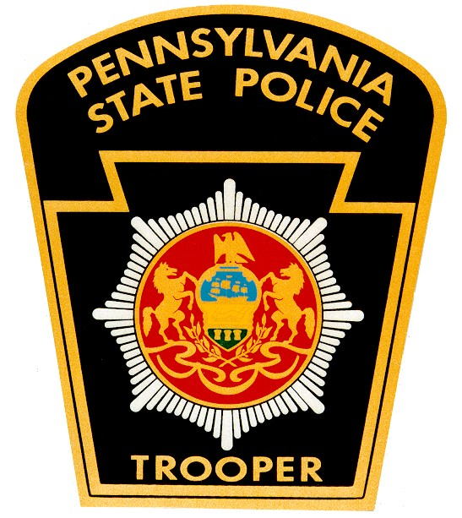
Questions? Contact Trooper Kelly MacIntyre at 610-486-6181

